## *Experiment No: 06*

## *Experiment Name:*

## Priority scheduling algorithm.

## *Discussion:*

## In this lab we learn Priority Scheduling Algorithm and its application in by c language program.

***Priority scheduling Algorithm:***

In priority scheduling algorithm each process has a priority associated with it and as each process hits the queue, it is stored in based on its priority so that process with higher priority are dealt with first. It should be noted that equal priority processes are scheduled in FCFS order.

To prevent high priority processes from running indefinitely the scheduler may decrease the priority of the currently running process at each clock tick (i.e., at each clock interrupt). If this action causes its priority to drop below that of the next highest process, a process switch occurs. Alternatively, each process may be assigned a maximum time quantum that it is allowed to run. When this quantum is used up, the next highest priority process is given a chance to run.

***Pseudo Code:***

#include<stdio.h>

int main()

{

int bt[20],p[20],wt[20],tat[20],pr[20],i,j,n,total=0,pos,temp,avg_wt,avg_tat;

printf("Enter Total Number of Process:");

scanf("%d",&n);

printf("\nEnter Burst Time and Priority\n");

for(i=0;i<n;i++)

{

printf("\nP[%d]\n",i+1);

printf("Burst Time:");

scanf("%d",&bt[i]);

printf("Priority:");

scanf("%d",&pr[i]);

p[i]=i+1; //contains process number

}

//sorting burst time, priority and process number in ascending order using selection sort

for(i=0;i<n;i++)

{

pos=i;

for(j=i+1;j<n;j++)

{

if(pr[j]<pr[pos])

pos=j;

}

temp=pr[i];

pr[i]=pr[pos];

pr[pos]=temp;

temp=bt[i];

bt[i]=bt[pos];

bt[pos]=temp;

temp=p[i];

p[i]=p[pos];

p[pos]=temp;

}

wt[0]=0; //waiting time for first process is zero

//calculate waiting time

for(i=1;i<n;i++)

{

wt[i]=0;

for(j=0;j<i;j++)

wt[i]+=bt[j];

total+=wt[i];

}

avg_wt=total/n; //average waiting time

total=0;

printf("\nProcess\t Burst Time \tWaiting Time\tTurnaround Time");

for(i=0;i<n;i++)

{

tat[i]=bt[i]+wt[i]; //calculate turnaround time

total+=tat[i];

printf("\nP[%d]\t\t %d\t\t %d\t\t\t%d",p[i],bt[i],wt[i],tat[i]);

}

avg_tat=total/n; //average turnaround time

printf("\n\nAverage Waiting Time=%d",avg_wt);

printf("\nAverage Turnaround Time=%d\n",avg_tat);

return 0;

}

***Output:***

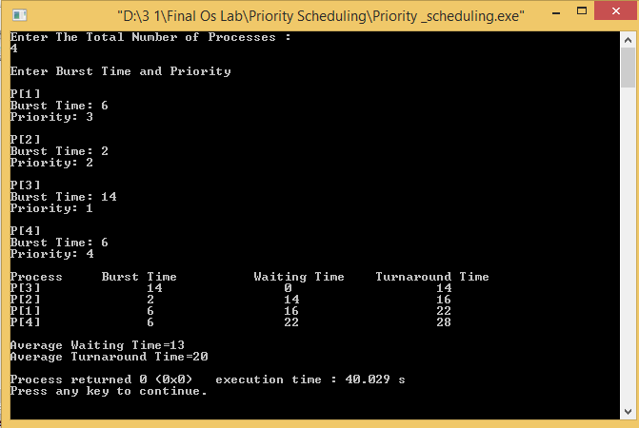

Discussion:

We finally completed our lab on Priority Scheduling and out respected course teacher helped us a lot to finish it successfully. Here we have observed that equal priority processes are scheduled in FCFS order